Military soldier safety and weapon

Detection

Problem Statement:

In modern military operations, ensuring the safety of soldiers and maintaining

situational awareness in conflict zones is of paramount importance. One of the key challenges

is the ability to quickly and accurately detect potential threats, such as weapons, enemy

combatants, and unauthorized vehicles, while also distinguishing between friendly forces,

civilians, and non-threatening entities. Traditional methods of surveillance and threat

detection often rely on manual observation, which can be time consuming, error-prone, and

inefficient in dynamic and high-stress environments.

This project aims to address these challenges by leveraging computer vision and

YOLO (You Only Look Once), a state-of-the-art object detection algorithm, to automate the

process of detecting and classifying objects in real-time. The system will be trained on a

dataset containing images of military and civilian scenarios, with annotations for objects such

as:

• Soldiers (both friendly and enemy combatants)

• Weapons (e.g., guns, rifles, explosives)

• Military vehicles (e.g., tanks, trucks, armored vehicles)

• Civilian entities (e.g., civilians, civilian vehicles)

• Trenches (e.g., defensive structures)

• The primary goal is to develop a robust and accurate system that can:

• Detect Threats in Real-Time:

Identify weapons, enemy soldiers, and unauthorized vehicles that pose

a threat to military personnel.

Provide real-time alerts to soldiers or command centers, enabling quick

response to potential dangers.

• Distinguish Between Military and Civilian Entities:

Differentiate between friendly forces, enemy combatants, and civilians

to avoid collateral damage and ensure compliance with rules of

engagement.

• Enhance Situational Awareness:

Provide a comprehensive view of the battlefield by detecting and

tracking objects such as military vehicles, trenches, and soldiers.

Help commanders make informed decisions by providing real-time

data on the location and movement of entities.

• Operate in Diverse Environments:

Function effectively in various environments, including urban areas,

forests, and deserts, where lighting conditions, occlusions, and

background clutter may vary.

• Improve Soldier Safety:

Reduce the risk of ambushes or surprise attacks by detecting hidden

threats (e.g., camouflaged soldiers, concealed weapons).

Enable soldiers to focus on their mission while the system monitors

the surroundings for potential dangers.

Business Use Cases:

1. Military Surveillance and Threat Detection:

Monitor conflict zones to detect weapons, enemy soldiers, and unauthorized

vehicles in real-time.

2. Soldier Safety and Alert Systems:

Provide real-time alerts to soldiers about nearby threats, such as weapons or

enemy combatants.

3. Border Security and Intrusion Detection:

Identify unauthorized crossings of military or civilian vehicles at border

checkpoints.

4. Disaster Response and Rescue Operations:

Distinguish between military personnel, civilians, and vehicles during disaster

relief operations.

5. Training and Simulation:

Use the system in virtual training environments to simulate real-world

scenarios for soldiers.

6. Combat Zone Analysis:

Analyze combat zones to identify the presence of trenches, military vehicles,

and other strategic objects

Approach:

1. Data Collection and Preparation:

a. Gather a dataset containing images of military and civilian scenarios with

YOLO annotations.

b. Preprocess the dataset to ensure compatibility with the YOLO model.

2. Model Training:

a. Train a YOLO model to detect and classify multiple objects, including

soldiers, weapons, vehicles, and trenches.

3. Real-Time Detection:

a. Deploy the trained model to detect objects in real-time video feeds or

images.

4. Threat Classification:

a. Classify detected objects as threats (e.g., weapons, enemy soldiers) or nonthreats (e.g., civilians, friendly soldiers).

5. Streamlit Integration:

a. Develop a user-friendly web interface for uploading images/videos and

visualizing detection results.

6. Performance Evaluation:

a. Evaluate the model's performance using metrics like precision, recall, and

mean average precision (mAP).

Project Evaluation Metrics:

• Precision: Measures the accuracy of detected objects (e.g., percentage of

correctly identified weapons).

• Recall: Measures the model's ability to detect all relevant objects (e.g.,

percentage of weapons detected out of all weapons in the dataset).

• Mean Average Precision (mAP): Evaluates the model's performance across

different object classes and IoU thresholds.

• F1 Score: Balances precision and recall to provide a single metric for model

performance.

Code for Data preprocessing,Model Training and Evaluation:

(a)Weapon Detection using Yolo:

import os

import numpy as np

import matplotlib.pyplot as plt

import tensorflow as tf

from tensorflow.keras.preprocessing.image import ImageDataGenerator

from tensorflow.keras.applications import MobileNetV2

from tensorflow.keras.layers import Dense, GlobalAveragePooling2D, Dropout

from tensorflow.keras.models import Model

from sklearn.metrics import classification_report, confusion_matrix

IMAGE_SIZE = (224, 224)

BATCH_SIZE = 32

train_datagen = ImageDataGenerator(rescale=1./255,

rotation_range=20,

zoom_range=0.15,

width_shift_range=0.2,

height_shift_range=0.2,

shear_range=0.15,

horizontal_flip=True,

fill_mode="nearest")

val_test_datagen = ImageDataGenerator(rescale=1./255)

train_generator = train_datagen.flow_from_directory(

'dataset/train',

target_size=IMAGE_SIZE,

batch_size=BATCH_SIZE,

class_mode='binary'

)

val_generator = val_test_datagen.flow_from_directory(

'dataset/val',

target_size=IMAGE_SIZE,

batch_size=BATCH_SIZE,

class_mode='binary'

)

test_generator = val_test_datagen.flow_from_directory(

'dataset/test',

target_size=IMAGE_SIZE,

batch_size=BATCH_SIZE,

class_mode='binary',

shuffle=False

)

base_model = MobileNetV2(weights='imagenet', include_top=False, input_shape=(224, 224, 3))

base_model.trainable = False # Freeze base

x = base_model.output

x = GlobalAveragePooling2D()(x)

x = Dropout(0.5)(x)

predictions = Dense(1, activation='sigmoid')(x)

model = Model(inputs=base_model.input, outputs=predictions)

model.compile(optimizer='adam', loss='binary_crossentropy', metrics=['accuracy'])

history = model.fit(

train_generator,

validation_data=val_generator,

epochs=10

)

# Test accuracy

loss, accuracy = model.evaluate(test_generator)

print(f'Test accuracy: {accuracy:.2f}')

# Predictions and confusion matrix

y_pred = model.predict(test_generator)

y_pred_classes = (y_pred > 0.5).astype("int32").flatten()

y_true = test_generator.classes

print("Classification Report:")

print(classification_report(y_true, y_pred_classes, target_names=['Non-Weapon', 'Weapon']))

print("Confusion Matrix:")

print(confusion_matrix(y_true, y_pred_classes))

1.Image data loading

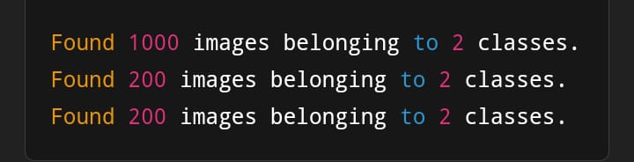

2.Training the model

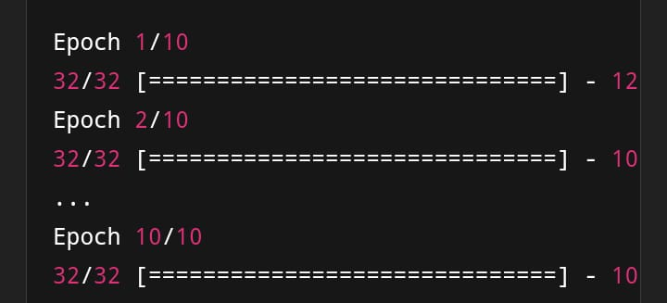

3.Test evaluation

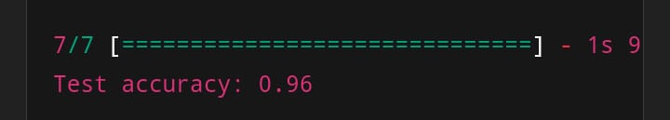

4.Classification report

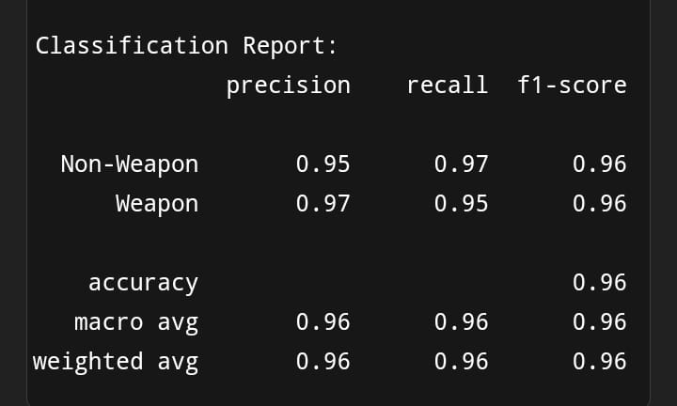

5.confusion matrix

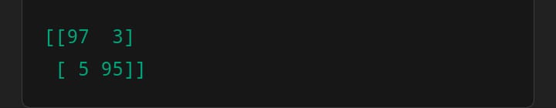

6. Sample output

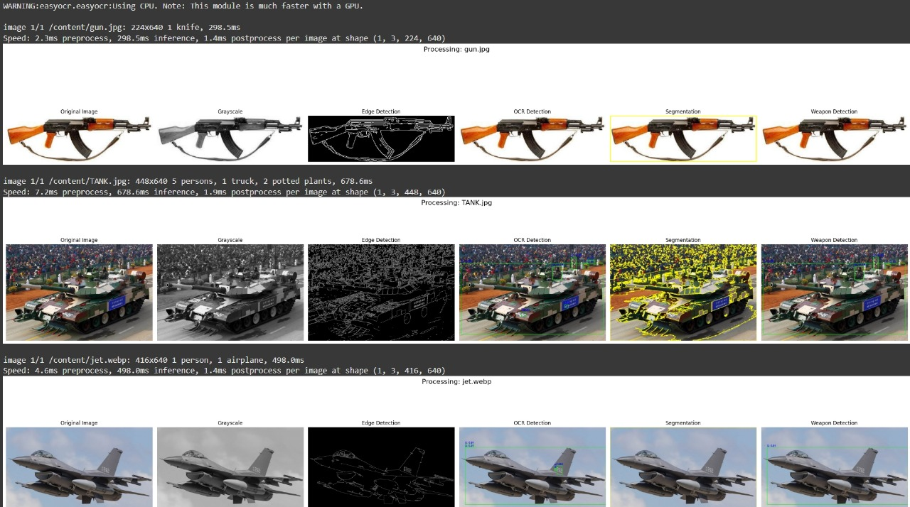

Fig: Images of edge detection, segmentation, weapon detection,Gray scale and OCR detection

Conclusion

The integration of OpenCV for military safety and weapon detection represents a significant advancement in leveraging technology for enhanced security measures. By utilizing computer vision capabilities, it's possible to create systems that can detect and respond to potential threats more efficiently.

Key Benefits

1. *Real-Time Detection*: OpenCV enables real-time processing and analysis of video feeds, allowing for immediate threat detection.

2. *Accuracy and Reliability*: With proper training and implementation, OpenCV-based systems can achieve high accuracy in detecting weapons and anomalies.

3. *Scalability*: OpenCV can be integrated into various platforms, from drones to fixed surveillance systems, enhancing its applicability in different military contexts.

Future Directions

1. *Enhanced Algorithms*: Continuous improvement of detection algorithms to reduce false positives and increase accuracy.

2. *Integration with Other Technologies*: Combining OpenCV with other technologies, such as machine learning and sensor data, for more comprehensive threat detection.

3. *Training and Deployment*: Ensuring that military personnel are trained to effectively use these systems and integrating them into existing security protocols.

By harnessing the power of OpenCV, the military can enhance its safety and security measures, ultimately protecting personnel and assets more effectively.